Experiment

Design an Obstacle Detector

Circuit diagram:

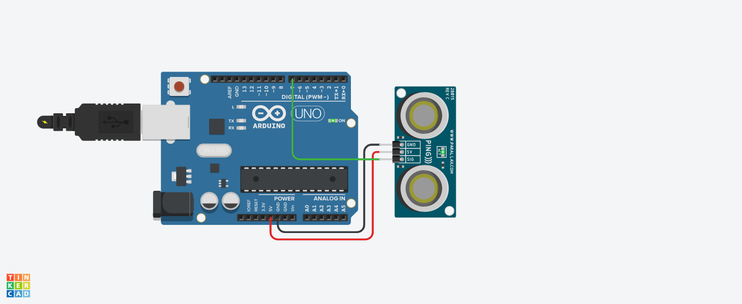

**Theory:**

# CONCEPT USED:

* **Byusingkirchoff’svoltagelaw**

&

* **Byusingkirchoff’scurrentlaw**
* **Seriesorparallelconnections**

# LEARNING ANDOBSERVATIONS:

* **ConnectionsinBreadboardandwiring.**
* **Howtocontrolarduinoanditscoding.**
* **Useofmultimeterforcontinuity.**

# OBSERVATION:

* **Blinkingofledsinapatternandinchasingform.**
* **Relationbetweensoftwareandhardware.**

# PROBLEMS &TROUBLESHOOTING:

* **Toselecttherightportandtypeofarduino**
* **Tocheckthelooseconnections**
* **Tochecktheconnectionsaccordingtothecodes**
* **Tocheckthecontinuityofthecircuit**
* **Tochecktheflowofcurrentinthecircuit**

# PRECAUTIONS:

* **Handle toolscarefully**
* **Weargloves**
* **Donotconnectarduinotillthecircuitiscomplete**

# OUTCOMES:

* **LEDsglowsinachasingpattern**
* **Itcanbeusedasfordecoratingpurpose**